Write a query to display  staff id, staff name,salary,dept id of all staff who get a salary greater than average salary of any department. Retrieve this details only for staff working for department 10.Sort the results in ascending order of staff id.

Note : Average salary should not be considered for any employee who has not been allocated any department.

Design Rules:

  1.Do Not Change the name of the column. Please use as per the design rules

  2.Order of the output columns : staff_id, staff_name,salary, dept_id

  3.Query output should have details only for dept id 10.

  4.Exclude staff who has not been assigned department while calculating average salary

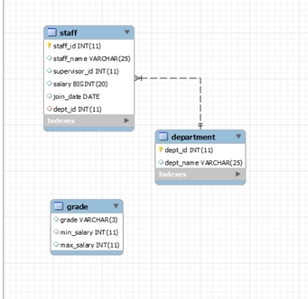

SELECT STAFF_ID, STAFF_NAME, SALARY, DEPT_ID FROM STAFF WHERE DEPT_ID = 10 AND SALARY > AVG(SALARY);